Election
Signage / Hoarding Guidelines

2022

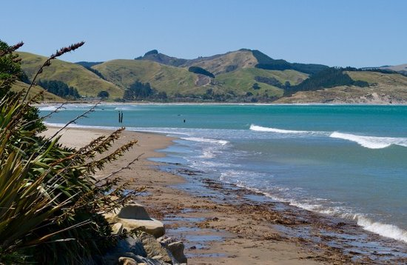
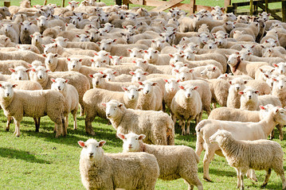

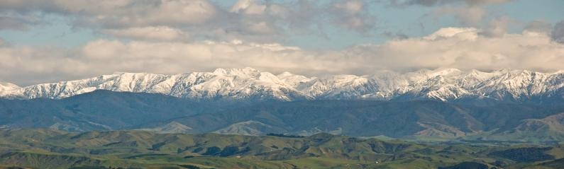
Prepared by the Tararua District Council Deputy Electoral Officer
July 2022

Election Signs

Temporary signs for elections are a permitted activity in the Tararua District, subject to compliance with the following standards:
- The area of any sign is no more than 4 m2.
- Signs are erected no more than 3 months prior to the election and removed by the eve of the day before the election day.
- Signs are located on private property or on road reserve (legal road) with the approval of the road controlling authority.
- Signs must be set back 3 metres from the edge of any “Road seal” to enable adequate vision to motorists of oncoming vehicles from intersections.
- Signs within the site of any heritage resource included in the Schedules in Appendix 2 of the District Plan, provided that the written approval to the erection of any such sign has been obtained from the New Zealand Historic Places Trust.
- No sign shall be permitted where it will detrimentally affect traffic safety and control by either:
  - Obstructing drivers' vision
  - Causing confusion or distraction for drivers
  - Creating a situation hazardous to the safe movement or direction of traffic

- No sign shall be permitted which restricts or blocks sight distances at intersections or access ways.
- The sign must be erected in a stable fashion, not be a hazard to the public or to traffic safety and must comply with the Tararua District Council District Plan / Bylaw.
- The site must be restored to the condition it was before the sign was displayed.

Signs that do not meet the standards can only be erected once resource consent has been obtained. Candidates should note that it takes at least 20 working days to obtain resource consent.

Election Candidates, campaigning must comply with the Local Electoral Act.

Tararua District Council has set aside designated areas on Council road reserve in Dannevirke, Woodville, Pahiatua and Eketahuna. No authorisation is required prior to the placement of signs; all signs must comply as listed above. The locations are listed in this hand-out.
Please note: You need to lodge a “before u dig” request to obtain service plans to identify any services that are within the areas of these selected locations.
Link: https://www.beforeudig.co.nz/nz/home

For further assistance on the locations detailed please contact Ray Cannon, Tararua Alliance on 06 374 5341.

The Electoral Officer
Tararua District Council
26 Gordon Street
Dannevirke
06 374 4088

Eketahuna

- Council Road Reserve grassed area from 70km limit on Newman Road up to intersection of Macara Street.

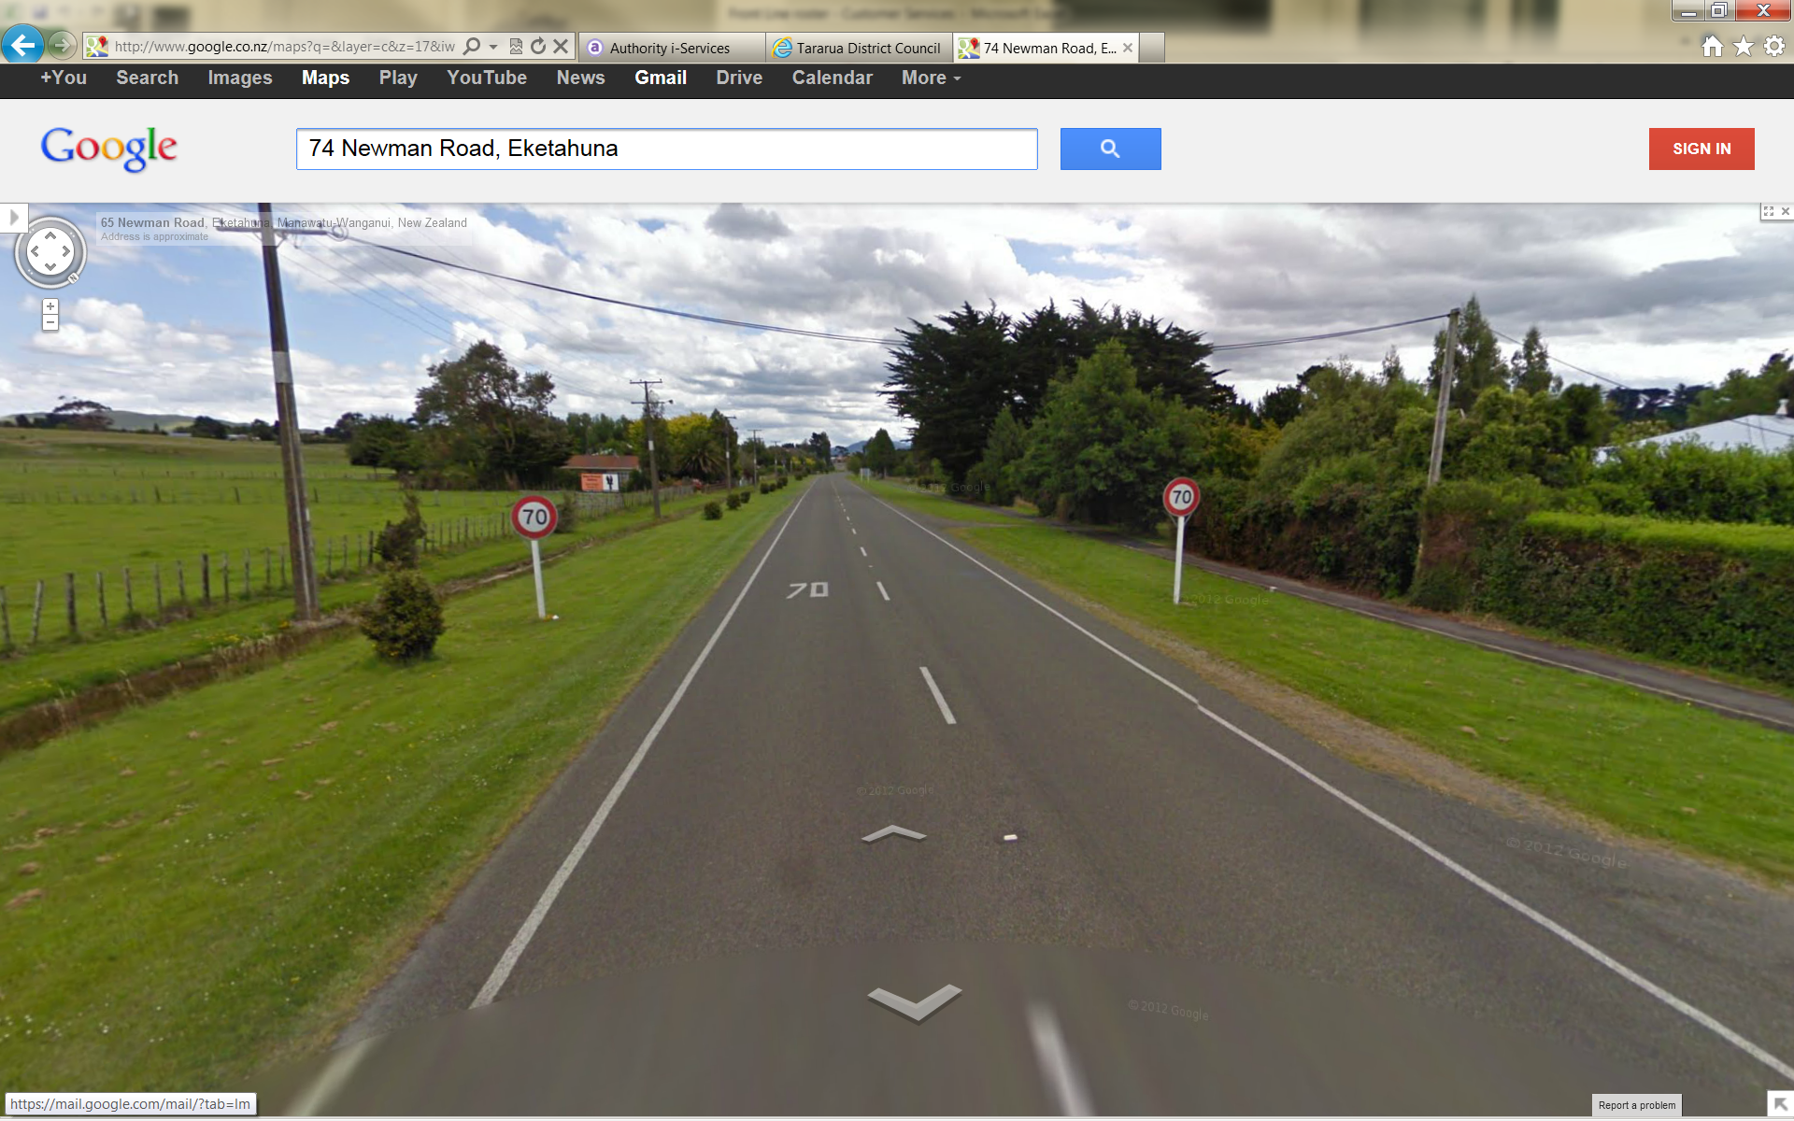

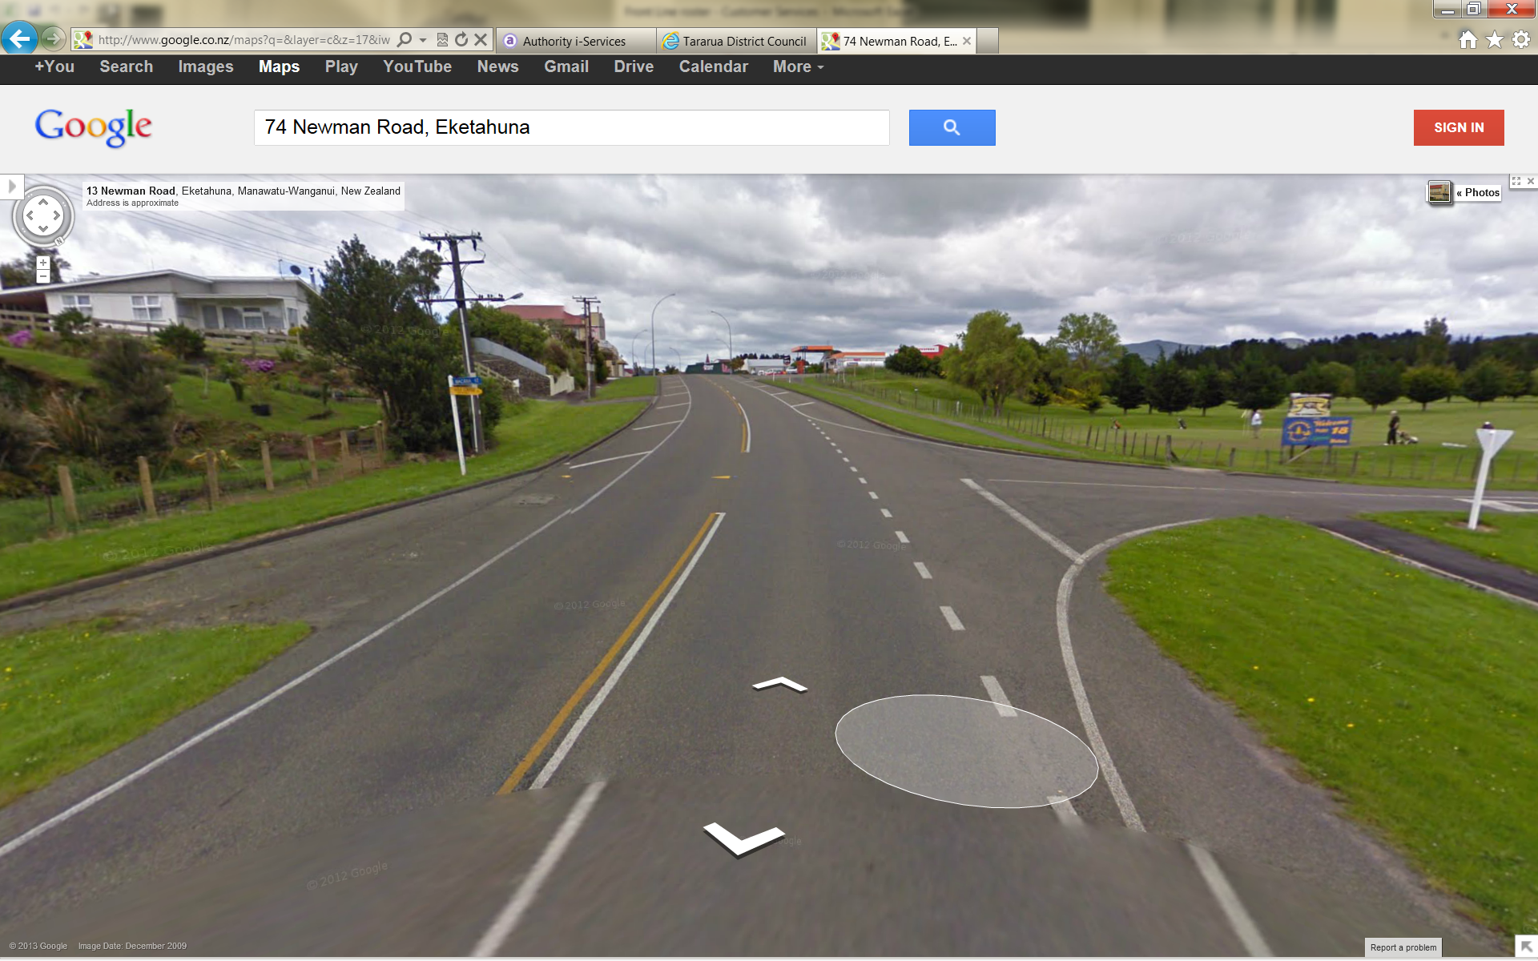

Pahiatua

- Council Road Reserve grassed area at northern town boundary.

- Council Road Reserve grassed area at southern town boundary.

Woodville

- Council Road Reserve, grassed area behind footpath, corner of Vogel and Fergusson Street.

Dannevirke

- Council Road Reserve, southern town boundary, grassed area, from State Highway 2 and Rawhiti Street intersection to the Stanley Street Tapuata River bridge.
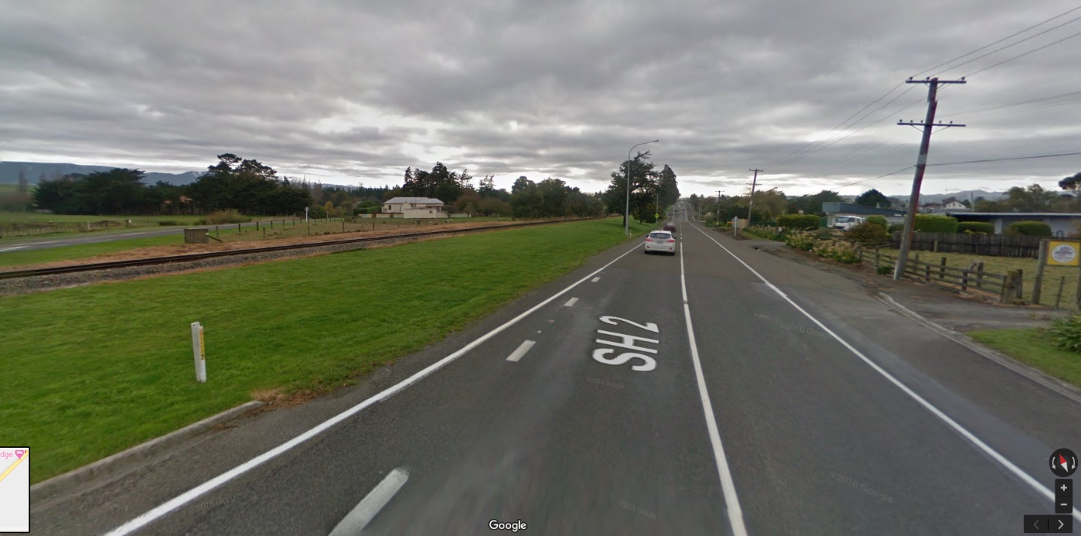

- Council Road Reserve, northern town boundary, grassed area behind footpath, corner of Ruahine Street and State Highway 2.

